Zpráva ze služební cesty v ČR

Jméno a příjmení účastníka cesty | Jitka Neoralová
Pracoviště – dle organizační struktury | 1.4.1http://www.icxom24.it/
Pracoviště – zařazení | Oddělení vývoje a výzkumných laboratoří – výzkumný pracovník
Důvod cesty | ICXOM24 – 24th International Congress on X-ray Optics and Microanalysis
Místo – město | Terst
Místo – země | Itálie
Datum (od-do) | 25. -30. 9. 2017
Podrobný časový harmonogram | 25. 9. 2017 Přílet do Terstu, ubytování  26. – 29. 9. 2017 Přednášky, prezentace, exkurze  30. 9. 2017 Odlet do Prahy
Spolucestující z NK
Finanční zajištění | IV 139
Cíle cesty | Účast na mezinárodní konferenci na téma aplikace rentgenových a optických technologií při ochranně kulturního dědictví.  Získání nových poznatků v oblasti interdisciplinární spolupráce v oboru péče, ochrany a analýz materiálů kulturního dědictví.  Navázání osobních kontaktů se zahraničními odborníky v dané oblasti, spolupráce na společných tématech, sdílení zkušeností.
Plnění cílů cesty (konkrétně) | Získání kontaktů na výrobce mapovacího XRF pro zobrazování spodních vrstev např. iluminací, předvedení automatického posunu. Konzultována spolupráce se zahraničními kolegy z Washington and Lee University (Erich Uffelman), University of Anteverp (prof. Koen, Janssens) Technickou univerzitou v Krakově (Pavel Wrobel, Artur Surowka), The Metropolitan Museum of Art (Louisa Smieska), CEITEC Brno (Tomáš Zigmund)a ČVUT v Praze.
Program a další podrobnější informace | Viz příloha
Přivezené materiály | Sborník abstraktů. Letáky dodavatelů analytických přístrojů. K dispozici v OVVL.
Datum předložení zprávy | 10. 10. 2017
Podpis předkladatele zprávy | Mgr. Jitka Neoralová
Podpis nadřízeného | Datum: | Podpis: Ing. P. Vávrová, Ph.D
Vloženo na Intranet | Datum: | Podpis:
Přijato v domácím oddělení | Datum: | Podpis:

Podrobná zpráva

Ve dnech 26. – 29. září 2017 se konala v italském Terstu 24. Mezinárodní konference rentgenoskopických technologií a mikroanalýz - ICXOM. Konference ICXOM je mezinárodní sympozium věnovaném vývoji a pokroku v oblasti technologií, přístrojového vybavení, metod a aplikací v oblasti rentgenové mikro- a nanoanalýzy. Konference se konají od roku 1956, kdy byla první ze série pořádána v Cambridge ve Velké Británii. Konference se začaly pořádat v reakci na poptávku odborníků z oborů fyziky, vývojářů technologií a těch, kteří využívají rentgenové mikroskopy a analýzy pomocí elektronových sond. V návaznosti na trendy v posledním desetiletí se konference zaměřila na využití synchrotronového záření. Neopomenut nebyl ani poslední vývoj laboratorních přístrojů na bázi XRF. Vedle mikrorentgenové fluorescence a absorpční spektroskopie byly prezentovány materiálové analýzy a zobrazovací techniky založené na rentgenové difrakci a full-field zobrazování v kombinovaných aplikacích v oblasti výzkum živé přírody, materiálových věd, geologických a environmentálních věd a v neposlední řadě také kulturního dědictví. Přednášky a prezentace se věnovaly těmto tématům: Optické technologie pro mikroanalýzu, skenovací mikroskopie
Zobrazování ve full-field (celoplošné), koherentní difraktivní zobrazování, mikrodifrakce, rentgenová fluorescence, absorpční spektroskopie, analýza dat z vybraných technologií a analýz, detektory. Prezentované aplikace v materiálových analýzách historických materiálů se zabývaly kovovými artefakty, identifikace zlacení, zobrazení vrstev maleb a polychromií či složení minerálních omítek. Součást konference byla odborná exkurze na pracovištích v synchrotronu Elettra a u výrobce speciálních magnetů KYMA Undulators. Kompletní program konference je přiložen na konci tohoto dokumentu.

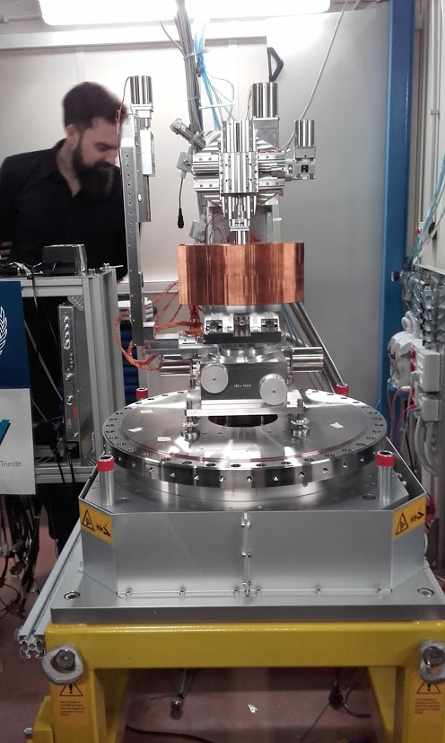 | 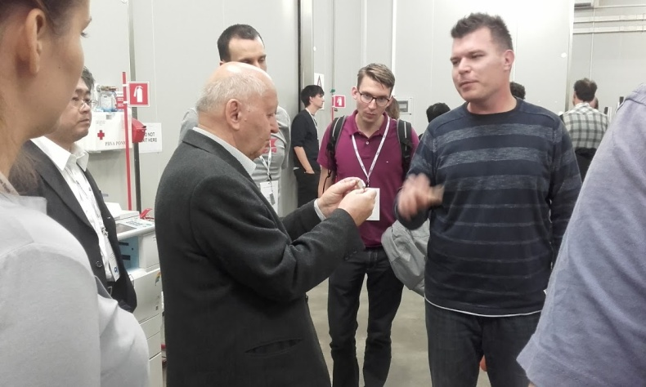
Mikro XRF v synchrotronu fy Elettra | Ukázka výroby speciálních magnetů ve firmě KYMA.

Tuesday, 26 September 2017
ICXOM24 conference
08:15 - 08:45 | Registration
Welcome
Chair: Alessandra Gianoncelli (Elettra Sincrotrone Trieste)
Room: Oceania ABC
08:45 | Alfonso Franciosi - Elettra Director and President  Welcome
09:00  09:10 | Zachary Lapin - Associate Editor, Nature Communications  Publishing with Nature Communications
X-ray Microscopy
Chair: Maya Kiskinova (Elettra Sincrotrone Trieste)
Room: Oceania ABC
09:10 | Burkhard Kaulich - Diamond Light Source Ltd  I08-SXM: The Scanning X-ray Microscopy Facility at the Diamond Light Source  Abstract
09:50 | Hyunjoon Shin - Pohang Accelerator Laboratory, POSTECH  A scanning soft x-ray microscope in absorption and fluorescence modes at the Pohang Light Source (PLS)  Abstract
10:10 | Yong Chu - Brookhaven National Laboratory  Nanoscale Multimodal Imaging Capability of the Hard X-ray Nanoprobe at the NSLS-II  Abstract
10:30  10:50 | Marie-christine Zdora - Diamond Light Source, University College London  X-ray phase-contrast imaging and metrology using periodic and random wavefront modulators  Abstract
10:50  11:20 |  | Conference picture & Coffee break
X-ray Microscopy and X-ray Fluorescence
Chair: Maya Kiskinova (Elettra Sincrotrone Trieste)
11:20 | Juergen Thieme (NSLS-II, USA)  X-ray Fluorescence Imaging and Spectroscopy with High Spatial Resolution at NSLS-II
12:00 | Laurence Lemelle - LGL-TPE, ENS de Lyon  Analytical requirements for quantitative X-ray fluorescence nano-imaging of metal traces in solid samples  Abstract
12:20 | Augusto Marcelli - Istituto Nazionale di Fisica Nucleare - Laboratori Nazionali di Frascati  Focusing and Diffraction Properties of Micro-Channel Plates for Transmitted X-ray Radiation  Abstract
12:40  13:00 | Chiara Gramaccioni - Univ. of Cosenza, CNR-Nanotec, Univ. Sapienza, Roma.  Nanotomography and X-Ray Fluorescence Microscopy for quantitative Iron concentration map in inflamed cells  Abstract
13:00  14:50 |  | Lunch
Detectors
Chair: Ralf Menk (Elettra Sincrotrone Trieste)
Room: Oceania ABC
14:50 | Peter Siddons (BNL, USA)  Multi-element Germanium Detectors for Synchrotron Applications
15:30 | Giovanni Bellotti - Politecnico di Milano and INFN Milano  ARDESIA: 4-Channels Fast SDD X-ray Spectrometer for Synchrotron Applications  Abstract
15:50  16:10 | Shaul Barkan - Hitachi High-Technologies  Seven-Element SDD with Optimized Packing Factor to Reduce Scattering Background  Abstract
16:10  16:40 |  | Coffee break
Detectors and Instrumentation
Chair: Ralf Menk (Elettra Sincrotrone Trieste)
Room: Oceania ABC
16:40 | Alessandro Migliori - International Atomic Energy Agency  X-ray microanalytical activities at the IAEA Nuclear Science and Instrumentation Laboratory
17:00  17:20 | Arthur Woll - Cornell University  Fast switching between 2D and direct, 3D XRF imaging using Collimating Channel Arrays and the Maia detector  Abstract
17:10  19:00 |  | Drinks and Poster Session

Wednesday, 27 September 2017
ICXOM24 conference
Tomography
Chair: Gerd Schneider (Helmholtz-Zentrum Berlin, Germany)
Room: Oceania ABC
08:30 | Marco Di Michiel - ESRF, France  Time resolved X-ray diffraction computed tomography for studying real systems under operando conditions
09:10 | Emanuel Larsson - Helmholtz-Zentrum Geesthacht, Germany  Evaluation of the XTM setup at the P05 Imaging Beamline at PETRA III using a sample of Nanoporous gold  Abstract
09:30 | Anton Maksimenko - Australian Synchrotron  Extreme Imaging with the synchrotron pink beam  Abstract
09:50 | Nicola Viganò - CWI, Netherlands  Inspecting sub-grain level deformation in poly-crystals  Abstract
10:10  10:30 | Anton Davydock - Helmholtz-Zentrum Geesthacht, Germany  P03 nanofocus end-station for material science  Abstract
X-ray Optics
Chair: François Polack (Soleil, Paris, France)
Room: Vulcania I
08:30 | Christian David - PSI, Switzerland  Diffractive X-ray Optics for Synchrotrons and Free Electron Lasers
09:10 | Pavel Dudin - Diamond Ltd, UK  Fresnel zone plates for nanoARPES  Abstract
09:30 | Jakob Soltau - Institute for X-Ray Physics, Goettingen, Germany  Imaging with Nanometer Resolution from 8 to 100 keV using Multilayer Zone Plates (MZP)  Abstract
09:50 | Evgeny Nazaretski - NSLS-II, USA  Fabrication and characterization of monolithic multilayer Laue lens nanofocusing optics for hard x-ray microscopy  Abstract
10:10  10:30 | Anatoly Snigirev - Immanuel Kant Baltic Federal university, Russia  Development of X-ray refractive optics for new diffraction limited X-ray sources  Abstract
10:30  11:00 |  | Coffee break
Tomography and Materials Science
Chair: Lucia Mancini (Elettra Sincrotrone Trieste)
Room: Oceania ABC
11:00 | Andrea Sorrentino - ALBA Light Source, Spain  Visualizing batteries discharge products at Mistral  Abstract
11:20 | Luigi Allocca - Istituto Motori - C.N.R., Italy  3-D structure of a gasoline spray by polycapillary X-ray micro-tomography  Abstract
11:40 | Samuel Flewett - Pontificia Universidad Católica de Valparaíso, Chile  Three-dimensional characterization of magnetic multilayer thin films using resonant soft X-ray scattering  Abstract
12:00  12:20 | Irina Snigireva - ESRF, France  Hard X-ray in-situ full-field microscopy for material science
Data Analysis for XRF and CT
Chair: Chris Ryan (CSIRO, Australia)
Room: Vulcania I
11:00 |  | Martin De Jonge - Australian Synchrotron, Australia  Fully-fractionated microprobe analysis  Abstract
11:20 |  | Matthias Alfeld - Sorbonne Universités, UPMC Univ Paris 06, CNRS, LAMS, France  Matrix Factorization for the near real time analysis of XRF imaging data  Abstract
11:40 |  | Mirna Lerotic - 2nd Look Consulting, Croatia  Analyzing 4D Tomographic X-Ray Spectromicroscopy Data with Mantis  Abstract
12:00  12:20 |  | Rongchang Chen - Shanghai Institute of Applied Physics, CAS, China  Monochromatic beam based quantitative dynamic micro computed tomography  Abstract
12:20  14:00 |  |  | Lunch
Detectors and Instrumentation
Chair: Peter Siddons (BNL, USA)
Room: Oceania ABC
14:00 | Anna Bergamaschi - PSI, Switzerland  Advances in hybrid pixel detectors for photon science  Abstract
14:40 | Stefan Brandstetter - Dectris Ltd, Switzerland  EIGER and PILATUS3 CdTe detector systems for advanced X-ray studies  Abstract
15:00 | Chris Ryan - CSIRO, Australia  Maia Mapper: High definition XRF imaging in the lab  Abstract
15:20 | Jeffrey Davis - PNDetector  High Speed, Simultaneous XRD-XRF Mapping  Abstract
15:40 | Benedikt Günther - Chair of Biomedical Physics, TUM; Max-Plank-Institute of Quantum Optics, Germany  The Munich Compact Light Source: Performance upgrades and biomedical research  Abstract
16:00 | Robert Mroczka - The John Paul II Catholic University of Lublin, Poland  Micro-X-Ray fluorescence spectrometer with X-ray single bounce gold capillary optics for light element analysis  Abstract
16:20  16:40 | Dariush Hampai - INFN - LNF, Italy  Volume Elemental Mapping in Confocal Geometry for Spectroscopy Studies of Biological Samples  Abstract
Ptychography and Phase Contrast
Chair: Georgios Kourousias (Elettra Sincrotrone Trieste)
Room: Vulcania I
14:00 | Michael Jones - Queensland University of Technology, Brisbane, Australia  Is the future bright for simultaneous X-ray ptychography and fluorescence microscopy?
14:40 | Bjoern Enders - Advanced Light Source, Lawrence Berkeley National Laboratory, USA  Higher dimensional ptychography at the ALS  Abstract
15:00 | Jan Garrevoet - DESY, Germany  Simultaneous XRF and Ptychographic imaging of FCC Particles  Abstract
15:20 | Qing Wu - Bern University of the Arts, Switzerland  Understanding the structure and aging of Zwischgold  Abstract
15:40 | Margie Olbinado - European Synchrotron Radiation Facility, France  Ultra high-speed X-ray phase-contrast imaging using single-pulse synchrotron radiation  Abstract
16:00  16:40 | Juliane Reinhardt - DESY, Germany & Australian Synchrotron  (Resonant) Hard X-ray Ptychography for High-Sensitivity Imaging with Chemical Contrast
17:10  19:00 |  | Coffee break and Poster Session

Thursday, 28 September 2017
ICXOM24 conference
Life Sciences
Chair: Gerald Falkenberg (DESY, Germany)
Room: Oceania ABC
08:30 | Lorella Pascolo - University of Trieste, Trieste, Italy  Elemental imaging at micro and nanoscale in toxicology research: from occupational diseases to reproductive medicines
09:10 | Maria Grzelak - AGH University of Science and Technology in Cracow, Poland  X-ray fluorescence imaging as a tool for recognition of different types of the ovarian cancer tissues  Abstract
09:30 | Erika Sales - Rio de Janeiro State University, Brazil  Characterization of cortical bone demineralization by X-ray-based techniques: A micro and nano scale study  Abstract
09:50 | Gert Nuyts - University of Antwerp, Belgium  X-ray based micro- and nanoimaging of nanoparticles in exposed biota  Abstract
10:10  10:30 | Carlo Meneghini - La Sapienza University, Rome, Italy  Investigating differences in Nanoscale distribution of trace metals in biominerals  Abstract
X-ray Optics and FEL
Chair: Marco Zangrando (Elettra Sincrotrone Trieste)
Room: Vulcania I
08:30 | François Polack - Soleil, Paris, France  X-ray optics, state of the art and current issues
09:10 | May Ling Ng - SLAC, Stanford University, USA  Stitching capabilities at the LCLS Metrology Laboratory  Abstract
09:30 | Angel Rodriguez Fernandez - Paul Scherrer Institut, Switzerland  Diagnostic of Forward Bragg Diffraction Hard X-ray beams for Self-Seeding applications SwissFEL  Abstract
09:50 | Mikhail Lyubomirskiy - DESY, Germany  Hard X-ray interferometers fabricated by Si planar technologies  Abstract
10:10  10:30 | Simone Sala - University College London, UK  Wavefront sensing using ptychography at FELs  Abstract
10:30  11:00 |  | Coffee break
Life Sciences and Environment
Chair: Lorella Pascolo (University of Trieste, Trieste, Italy)
Room: Oceania ABC
11:00 | Katarina Vogel Mikuš - University of Ljubljana and Joseph Stefan Institute, Slovenia  Imaging of chemical composition in plant tissues: revealing physiological mechanisms to improve food quality and safety
11:40 | Zou Finfrock - Canadian Light Source Inc.  Confocal X-Ray Fluorescence Microscopy at the Advanced Photon Source Sector 20  Abstract
12:00 | Christopher Heirwegh - Jet Propulsion Laboratory, California Institute of Technology  A first look at the quantification capabilities of the prototype Mars 2020 Planetary Instrument for X-ray Lithochemistry  Abstract
12:20  12:40 | Alexandre Simionovici - ISTerre, Univ. Grenoble Alpes  QESA - Quarantine Extraterrestrial Sample Analyses: methodology and setup  Abstract
X-ray Optics and FEL
Chair: Christian David (PSI, Switzerland)
Room: Vulcania I
11:00 | Alexander Firsov - Helmholtz Zentrum Berlin, Germany  Diffractive/Reflection optical elements. From Bragg reflection to total external reflection  Abstract
11:20 | Corey Hardin - SLAC National Accelerator Laboratory, USA  Wavefront preserving mirrors at LCLS  Abstract
11:40 | Kazushi Sumitani - Japan Synchrotron Radiation Research Institute  Development of kinoform lenses made of quartz for microbeam X-ray diffraction  Abstract
12:00 | Jörn Volkher Wochnowski - Professor at the University of Applied Sciences Luebeck  Coated Hollow Capillaries as X-Ray Optics  Abstract
12:20  12:40 | Elisa Kornemann - Karlsruhe Institute of Technology  Miniaturized X-ray zoom lens  Abstract
12:40 |  | Lunch

Optics system
Chair: Ralf Menk (Elettra Sincrotrone Trieste)
Room: Vulcania I
14:15 | Jared Sachs - XOS  Optimized High Energy Performance of Polycapillary Optics for µXRF Analysis  Abstract
14:30 | Malcolm Lindqvist - Excillum AB, Sweden  Polycapillary Optic for Liquid-Metal-Jet X-Ray Tubes  Abstract
14:45 | Luca Peverini - Thales SESO SAS  Optimized High Energy Performance of Polycapillary Optics for µXRF Analysis  Abstract
15:00 |  | Visit to Elettra and Kyma

Friday, 29 September 2017
ICXOM24 conference
Full-field and tomography
Chair: Juergen Thieme (NSLS-II, USA)
Room: Oceania ABC
08:30 | Gerd Schneider - Helmholtz-Zentrum Berlin, Germany  Nanoscale spectroscopy and tomography with the HZB full-field transmission X-ray microscope
09:10 | Fabio Alessio Vittoria - University College London, UK  Beam tracking phase tomography with laboratory sources  Abstract
09:30 | Tomas Zikmund - CEITEC BUT, Brno University of Technology  Comparison of CCD and sCMOS Detector for Sub-micron Resolution in Lab-based X-ray Computed Tomography  Abstract
09:50 | Phil Cook, ESRF, France  X-rays, microscopy, and rock and roll  Abstract
10:10  10:30 | Pawel Wrobel - AGH University of Science and Technology in Cracow  The Full-Field XRF Imaging System For Investigation Of Paintings  Abstract
10:30  11:00 |  | Coffee break
Cultural Heritage
Chair: Franco Zanini (Elettra Sincrotrone Trieste)
Room: Oceania ABC
11:00 | Loic Bertrand - IPANEMA CNRS MCC UVSQ MNHN  Discrimination of organic compounds in ancient and historical materials with in situ synchrotron-based X -Ray Raman scattering  Abstract
11:20 | Paula Allegro - Institute of Physics, University of São Paulo  Monte Carlo simulation and EDXRF analysis of the pigments used in “Natura Morta” (1946) by Mario Mafai  Abstract
11:40 | Wantana Klysubun - Synchrotron Light Research Institute  Synchrotron XRF/XAS Applications on Heritage glasses in Thailand  Abstract
12:00 | Martin Radtke - Bundesanstalt für Materialforschung und –prüfung (BAM)  The Bernstorf Gold u2013 A Challenge to the Flexibility of SRXRF  Abstract
12:20  12:40 | Karen Cloete - iThemba Laboratory for Accelerator Based Sciences, National Research Foundation  In-air PIXE, MeV-SIMS, and DAPNe-MS: a multidimensional analytical approach for unlocking chemical information in scalp hair  Abstract
Room: Oceania ABC
12:40  13:00 | Alessandra Gianoncelli (Elettra Sincrotrone Trieste)  Concluding remarks
Confirmed Invited Speakers
The following scientists have already agreed to give invited talks:
Anna Bergamaschi (PSI, Switzerland) - Advances in hybrid pixel detectors for photon science
Christian David (PSI, Switzerland) - Diffractive X-ray Optics for Synchrotrons and Free Electron Lasers
Burkhard Kaulich (Diamond Light Source, UK) - I08-SXM: The Scanning X-ray Microscopy Facility at the Diamond Light Source
Marco di Michiel (ESRF, France) - Time resolved X-ray diffraction computed tomography for studying real systems under operando conditions
Lorella Pascolo (University of Trieste, Trieste, Italy) - Elemental imaging at micro and nanoscale in toxicology research: from occupational diseases to reproductive medicines '
François Polack (Soleil, Paris, France) - X-ray optics, state of the art and current issues
Juliane Reinhardt (DESY, Germany) - (Resonant) Hard X-ray Ptychography for High-Sensitivity Imaging with Chemical Contrast
Gerd Schneider (Helmholtz-Zentrum Berlin, Germany) - Nanoscale spectroscopy and tomography with the HZB full-field transmission X-ray microscope
Pete Siddons (BNL, USA) - Multi-element Germanium Detectors for Synchrotron Applications
Juergen Thieme (NSLS-II, USA) - X-ray Fluorescence Imaging and Spectroscopy with High Spatial Resolution at NSLS-II
Michael Jones (Queensland University of Technology, Brisbane, Australia) - Is the future bright for simultaneous X-ray ptychography and fluorescence microscopy?
Katarina Vogel Mikuš (University of Ljubljana and Joseph Stefan Institute, Slovenia) - Imaging of chemical composition in plant tissues: revealing physiological mechanisms to improve food quality and safety

